Position Description
Electrical Engineer - Industrial

2019

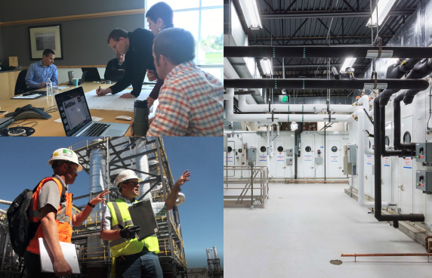

Position Specification
Position Electrical Engineer - Industrial
Organization KFI Engineers (KFI)
Location St. Paul, MN
Reporting Relationship Senior Electrical Engineer
Website http://www.kfiengineers.com/

COMPANY BACKGROUND
KFI is a recognized industry leader in process and facility infrastructure design and performance. We serve clients in the United States, Canada and Central America and have capabilities not commonly found in traditional engineering firms, including our commissioning work and our ability to drive projects of all sizes.

KFI was established in 1996 to make a difference in the way infrastructure and processing projects are delivered. We employ a highly trained staff of engineers, technicians and managers who execute projects with the same care and creativity we would expect if we were the client. We are located in Minnesota, Wisconsin, Iowa, and North Dakota with a team of 100 professionals.
POSITION Overview
The Electrical Engineer plays a key role in the successful execution of projects. Reporting to the Senior Electrical Engineer, Industrial, this individual will provide technical and engineering excellence, as well as successful delivery of work to our customers. KFI’s industrial group focuses on process and utility facility infrastructure design and performance. Traditionally, much of our work takes place within these markets: biofuels, agribusiness, utilities and manufacturing. We also assist clients with these services in developing Campus master plans, which include organizations such as higher education, healthcare, manufacturing and government. We deliver total project management on many projects, including processing, utility, and power distribution systems.
The Electrical Engineer is responsible for a high level of customer satisfaction by ensuring expectations are clearly communicated and managed – both externally and internally. The successful candidate will also contribute to a dynamic team environment by being proactive, communicating clearly to all stakeholders, and modeling a highly collaborative working environment. This person may also support the business development process, by contributing to proposals and meeting with prospective and current customers.
typical RESPONSIBILITIES
Specific responsibilities will include, but not be limited to, the following:
- Designs one or more of the following: medium voltage and 480 volt power generation and distribution systems (primary requirement).
- Designs non-commercial building power and lighting systems. Includes the design of special systems, such as ground fault, lightning protection, engine-generator, UPS, DC, etc.
- Prepares engineering documents and equipment specifications to meet contracted scope of work and to ensure application of Electrical Engineering Principles including single-line diagrams, plans, schedules, schematics and details.
- Performs power system studies, including arc fault hazard analysis, short circuit, load flow, protective device coordination and harmonics studies, using SKM PTW.
- Reviews and approves contractor submittals, conducts construction observation and provides field support during startup and commissioning of electrical systems and equipment.
- Develops labor/cost estimates for assigned scope of work, and is accountable for ensuring we stay within scope and budget.
- Creates project plans and schedules for the execution of work.
- May serve as project manager for complete projects, when assigned.
- Supports the business development process through input to proposals, meeting and interviewing with prospective customers, etc.
- Provides work direction to other team members, including subcontractors, as assigned.
- Provides technical and engineering support to other departments/disciplines.
knowledge, skills and abilities required
The successful candidate will have a pragmatic and applied approach, while at the same time bringing a creative examination of customer needs and solutions.

The successful candidate will have strong electrical design experience across a variety of industries and processes. Project experience and/or working knowledge of Process, Instrumentation & Controls will be very valuable. This person possesses a basic understanding of Electrical, Mechanical, Civil and Structural Engineering construction practices. He/she has a strong knowledge of Codes and industry standards (e.g. NEC, NFPA, NESC, ANSI/IEEE, etc.).

This person will have strong interpersonal skills to enable effective interaction with Designers, Engineers and Project Managers. This person will also possess strong communication skills, and influencing skills, and has demonstrated the maturity and self-confidence to work with colleagues and customers. The level of seasoning we are looking for likely comes with a minimum of 10 - 12 years of experience following graduation.

The successful candidate will be naturally collaborative, and possess the ability to assimilate a range of ideas, programs or alternatives into a set of recommendations. This person will be self-directed, but thrive in an environment where consultation leads to superior outcomes.

Additional qualifications the successful candidate will possess include:
- Effective meeting management skills.
- Strong attention to detail.
- Adaptable and agile, responsive to quick changes in direction.
- Ability to establish rapport and credibility with customers and other stakeholders.
Key Performance Characteristics
Understanding the Business
- Knows the business and the mission-critical technical and functional skills needed to do the job; understands the “KFI way” – our Mission, Vision and processes. Learns new methods and technologies easily.
Getting Organized
- Is well organized, resourceful, and planful; effective and efficient at marshalling multiple resources to get things done; lays out tasks in sufficient detail to mark the trail; is able to get things done with less and in less time; can work on multiple tasks at once without losing track; foresees and plans around obstacles.
Focusing on Action and Outcomes
- Attacks everything with drive and energy with an eye on the bottom line; not afraid to initiate action before all the facts are known; drives to finish everything he/she starts.
Focusing on the Customer
- Identifies and anticipates customer requirements, expectations, and needs. Creates systems and processes that make it easy for customers to do business with the company. Ensures that customer issues are resolved.
Communicating Effectively
- Writes and presents effectively; adjusts to fit the audience and the message; strongly gets a message across.
Influencing Others
- Ensures that proposals or arguments are supported by strong logic and a compelling business case, addressing all relevant factors. Identifies the agendas, concerns, and motivations of others.
Builds Relationships
- Treats people with respect; relates well to people regardless of their organization level, personality, or background. Encourages others to express their views, even those contrary to current thinking.
EDUCATION
A Bachelors’ degree in Electrical Engineering and Professional Engineering registration in Minnesota, or the ability to obtain Minnesota registration via comity are required. P.E. registration in other states is desirable but not required.

KFI ENGINEERS CONTACT
Lee Anne Roy
Human Resources
670 County Road B West
Roseville, MN 55113
careers@kfi-eng.com

